Task 4 Report

Code Explanation
This tasks code builds upon the previous tasks function such as load_data from task 2. The first new function is the create_custom_model function. This takes 3 arguments. The sequence length (similar to the lookup_steps variable from before), the number of features (such as Open, Volume, Adj Close) and an array of layers that will define the model.
I created a simple class for these layers that contain the layer type (LSTM/GRU) and the size of the layer. This way we can simply create an array of these layer objects and pass it into the model creation function.
The function itself is pretty simple. First, we define the model as sequential. Then, for every layer we either add an LSTM or GRU layer, followed by a dropout layer with a hard coded value of 0.3 for now. Importantly the first layer of the model must have an input (defined with batch_input_shape) and the final layer needs to not return any data.
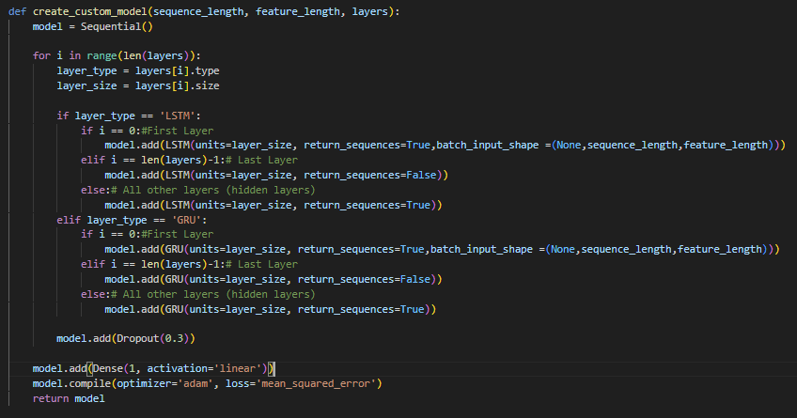
When compiled the model should look something like this:
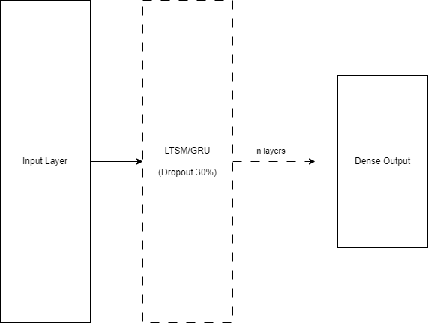

The other custom(ish) function is used to convert the data and models predicted data back into usable values. This function was directly taken from project P1 but is integral to plotting the data. In short, this function reshapes the y data, being the models’ output data, by first assuring the correct shape for transformation, then reverting the values back into its original dollar scale rather than unit values between 0 and 1. Squeeze is then used to remove unnecessary array dimensions.
It's worth noting that “Adjust Close” is still used as the presumed column that we want to predict values against.
Finally, the index/date column is sorted to assure the data is in chronological order.
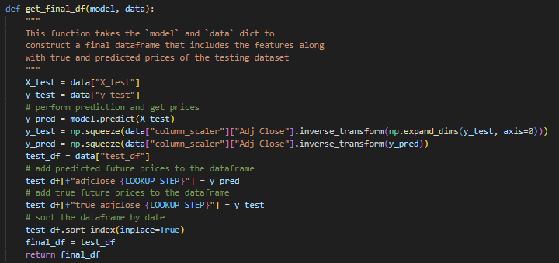

Putting all of this together:
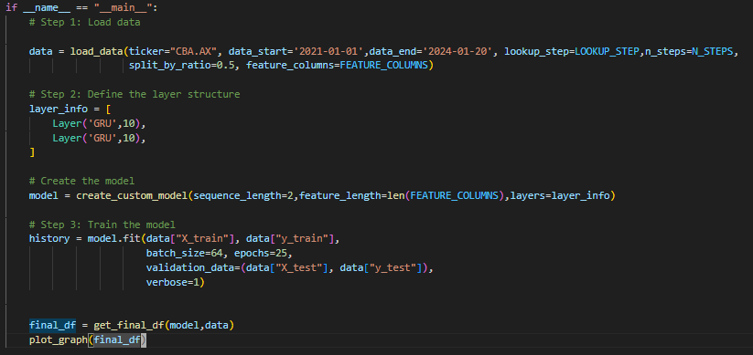
Of note here is that two GRU layers have been used for simplicity of testing, and plot_graph simply plots both the actual and predicted closing values against their respective dates.

Experimentation

Experiment 1.1 – LSTM Parameters
LTSM | 2 Layers | 8 Layers
Size 10 | 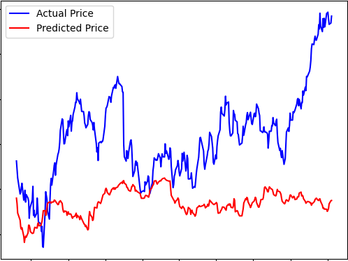 | 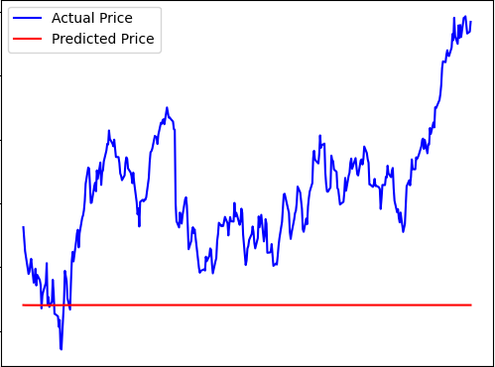
Size 50 | 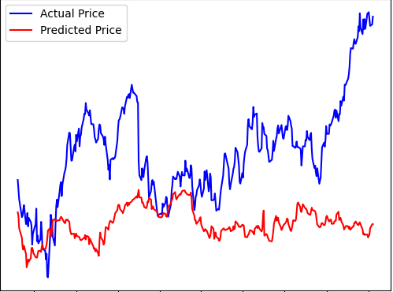 | 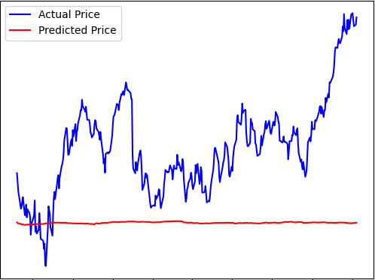

Experiment 1.2 – GRU Parameters
GRU | 2 Layers | 8 Layers
Size 10 | 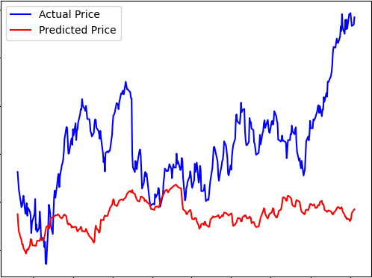 | 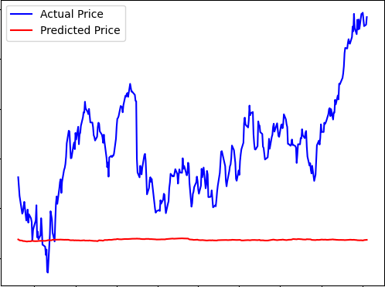
Size 50 | 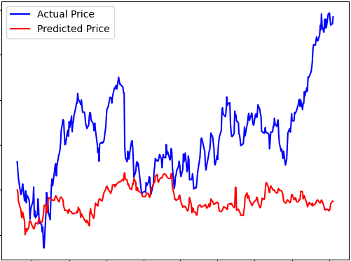 | 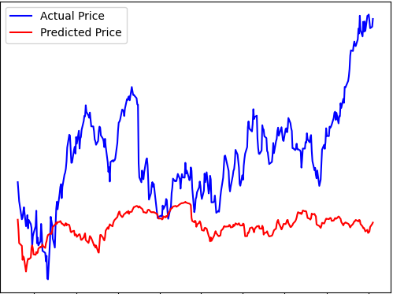

Experiment 2 - Hybrid Layers
GRU/LSTM | 25% Split | 50% Split
4 Layers | 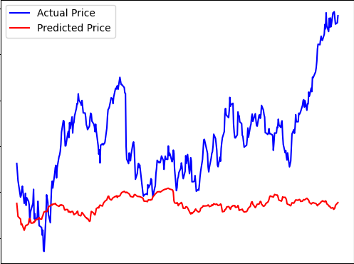 | 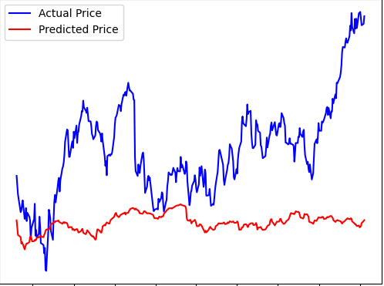
8 Layers | 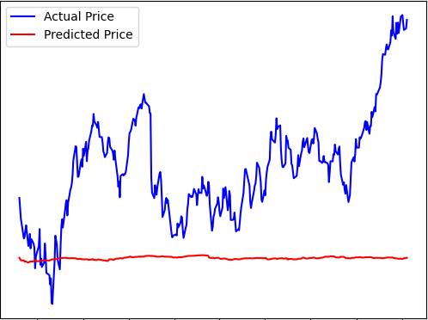 | 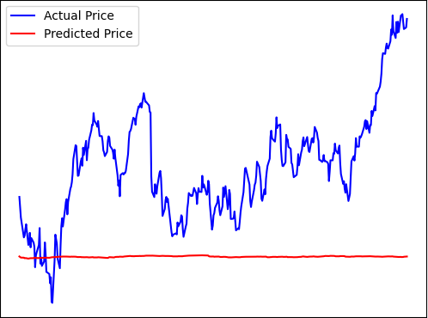

Experiment 3 - Testing Modification
 | 10 Epochs | 25 Epochs | 50 Epochs
64 Batches | 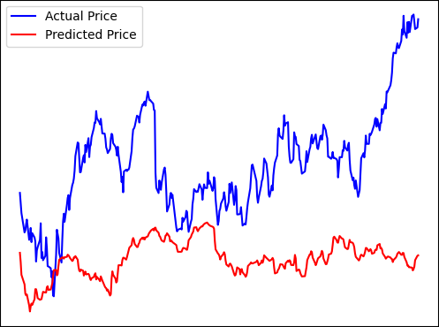 | 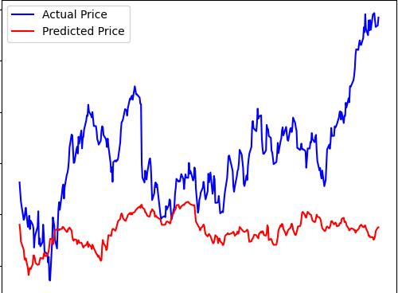 | 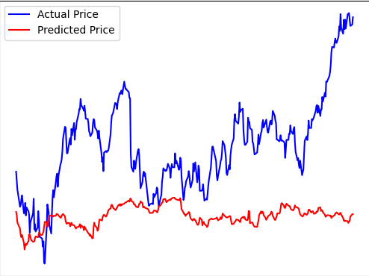
128 Batches | 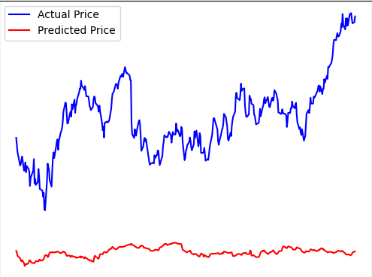 | 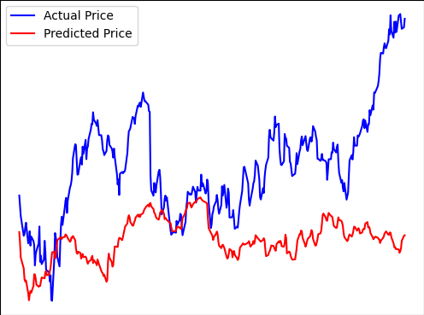 | 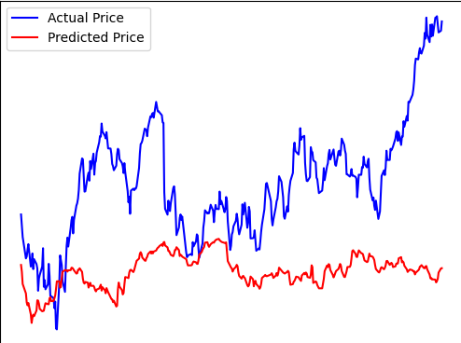

Experiment 4 – Lookup Sizes
Lookup_Step 10 | 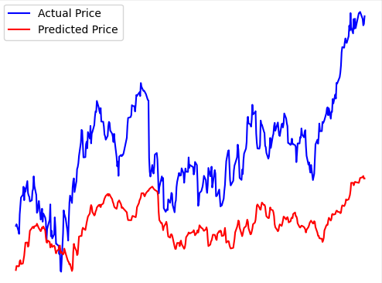
Lookup_Step 50 | 
Lookup_Step 100 | 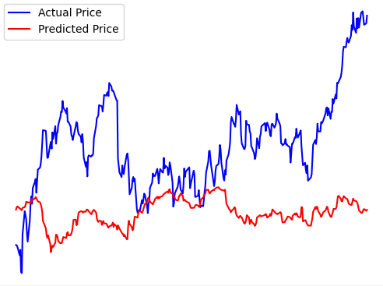

Discussion
These first two experiments look at the effects of altering the layer size and number of layers using both the LSTM and GRU models. Clearly in this case using too many layers proves harmful to the accuracy of the model. I’d posit from these graphs that the sheer number of layers is adding in too much noise to produce a useful result that isn’t a flat average value. However, it does look like the size of the layers helps the volatility of final output. Specifically, the larger the size looks like increase the likelihood of spikes in the data. With this said there doesn’t seem to be a difference between the success of using LTSM or GRU only layers as all predictions in experiment 1.1 and 1.2 are extremely similar.
Experiment 2 focuses on the effect of using a mix of LTSM and GRU layer types. Once again, we can see using too many layers tarnishes the accuracy of the results. However, the percentage at which each layer type is used seems to have no effect. Although omitted from the results, I also experimented with the order at which these layers were used but similarly achieved no difference in results.
Experiment 3 proved somewhat successful at improving the accuracy of the results. Clearly too many batches with too little training were un-helpful, but this experiment also showed that too much training also achieved slightly sub-optimal results. In this case I would put the 128 batch, 25 epoch result as the best of the tests. Perhaps it’s a nice mix between batch size and not too much training that means we can train a reasonable amount of the data without attempting to over fit the results.
Experiment 4 also showed a clear difference in results. This experiment altered the amount at which previous data is used to predict a future result. Here we can see what looks like a temporal shift in the output data. The greater the lookup_step the further the actual data’s shape is projected in time onto the predicted data’s shape.
Putting all of this together I ran one last test taking what I thought to be the best parameters from each experiment. Here is the final output using:
- Lookup_Step of 10
- Batch size 128
- Epochs 25
- 2 LSTM Layers of Size 20
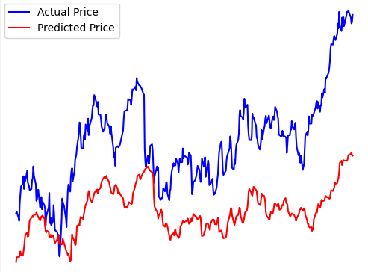
While there is still much improvement to be desired, this is clearly a major improvement over the result of all the previous testing.

